The Inbetweeners : Team Name ............................
From the year 2000 onwards the British Open Golf Championship has been won by ten different men :  Who are they : |  | 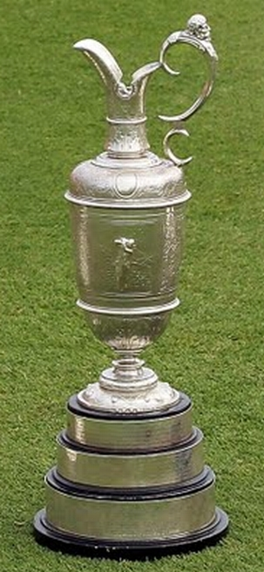 |  | There have been ten previous series of the BBC Strictly Come Dancing television programme.  Name the celebrity winners.  Their initials and the year they won are provided to help you. |  |  |  | 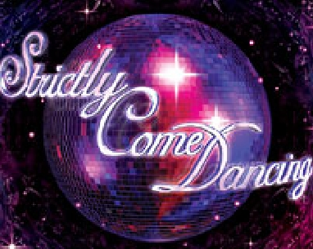
1 |  |  |  | 1 | N K | May  2004
2 |  |  |  | 2 | J H | Oct  2004
3 |  |  |  | 3 | D G | 2005
4 |  |  |  | 4 | M R | 2006
5 |  |  |  | 5 | A D | 2007
6 |  |  |  | 6 | T C | 2008
7 |  |  |  | 7 | C H | 2009
8 |  |  |  | 8 | K T | 2010
9 |  |  |  | 9 | H J | 2011
10 |  |  |  | 10 | L S | 2012

